
http://ids-adi.org

POSC Caesar – FIATECH
Intelligent Data Sets - Accelerating Deployment of ISO15926
Realizing Open Information Interoperability

Reference Data Editor Document
Version 1.1

Revision History
Document Version # | Action Taken, Notes | Date | Name
1.1 | Second release | 23 Sep, 2009 | Pavan Dubey

Terms of License
Copyright (c) 2009, ids-adi.org
All rights reserved.

Redistribution and use in source and binary forms, with or without
modification, are permitted provided that the following conditions are met:
* Redistributions of source code must retain the above copyright
notice, this list of conditions and the following disclaimer.
* Redistributions in binary form must reproduce the above copyright
notice, this list of conditions and the following disclaimer in the
documentation and/or other materials provided with the distribution.
* Neither the name of the ids-adi.org nor the
names of its contributors may be used to endorse or promote products
derived from this software without specific prior written permission.

THIS DOCUMENT IS PROVIDED BY ids-adi.org ''AS IS'' AND ANY
EXPRESS OR IMPLIED WARRANTIES, INCLUDING, BUT NOT LIMITED TO, THE IMPLIED
WARRANTIES OF MERCHANTABILITY AND FITNESS FOR A PARTICULAR PURPOSE ARE
DISCLAIMED. IN NO EVENT SHALL ids-adi.org BE LIABLE FOR ANY
DIRECT, INDIRECT, INCIDENTAL, SPECIAL, EXEMPLARY, OR CONSEQUENTIAL DAMAGES
(INCLUDING, BUT NOT LIMITED TO, PROCUREMENT OF SUBSTITUTE GOODS OR SERVICES;
LOSS OF USE, DATA, OR PROFITS; OR BUSINESS INTERRUPTION) HOWEVER CAUSED AND
ON ANY THEORY OF LIABILITY, WHETHER IN CONTRACT, STRICT LIABILITY, OR TORT
(INCLUDING NEGLIGENCE OR OTHERWISE) ARISING IN ANY WAY OUT OF THE USE OF THIS
SOFTWARE, EVEN IF ADVISED OF THE POSSIBILITY OF SUCH DAMAGE.
Table of Contents

POSC Caesar – FIATECH Intelligent Data Sets - Accelerating Deployment of ISO15926 Realizing Open Information Interoperability 1
Reference Data Editor Document 1
1.0 Layout of Reference Data Editor Homepage 4
2.0 Search Process 5
3.0 Promoting an item to a new tab window 8
4.0 Adding a class into sandbox 10
4.1 Adding Class process 11
4.2 Editing Class process 12
5.0 Adding a template into sandbox 13
5.1 Adding Template process 14
5.2 Editing Template process 15

Layout of Reference Data Editor Homepage

Reference Data Editor home page has following components:
- A Search Field Box
- A pane on the left side for showing search results in a new Tab window for each search criterion
- A pane on the right side for showing details of selected item from search results
- ‘Promote’ option for promoting an item to a new tab window
- ‘Add Class’ option for adding a class in sandbox
- ‘Edit Class’ option for editing a class in sandbox
- ‘Add Template’ option for adding template in sandbox
- ‘Edit Template’ option for editing template in sandbox

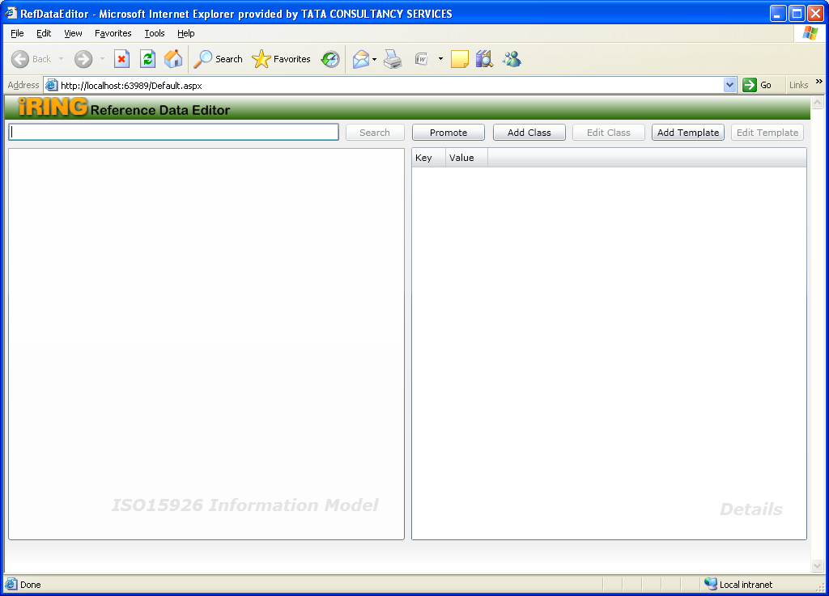

Search Process

- User enters search criterion in Search Field. Based on search criterion; the search results pane on the left displays results in chunks of 100 in a new tab window. For each search a new tab window is added to the pane on left side so user can have multiple tab window
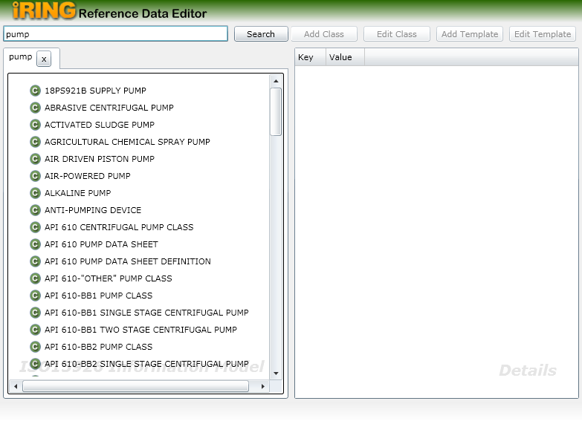

- Following screen is showing multiple tab windows added to pane on left side

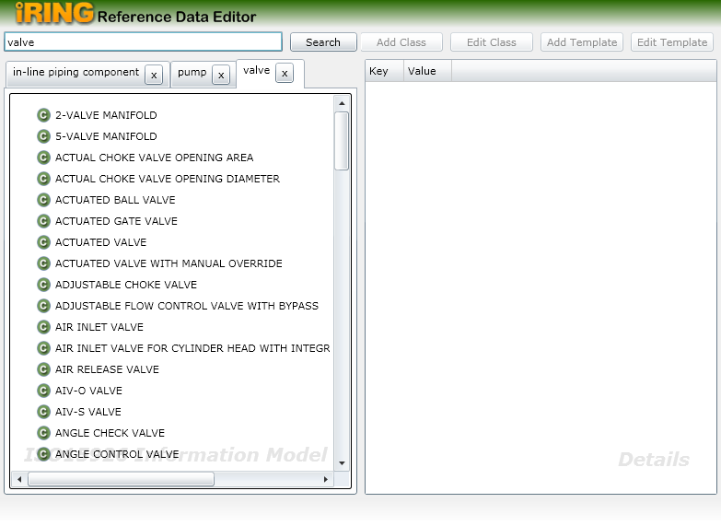

- Upon selection of any item from search results four new templates (Classifications, Super Class, Sub Classes and Templates) are added to the selected items. Like following
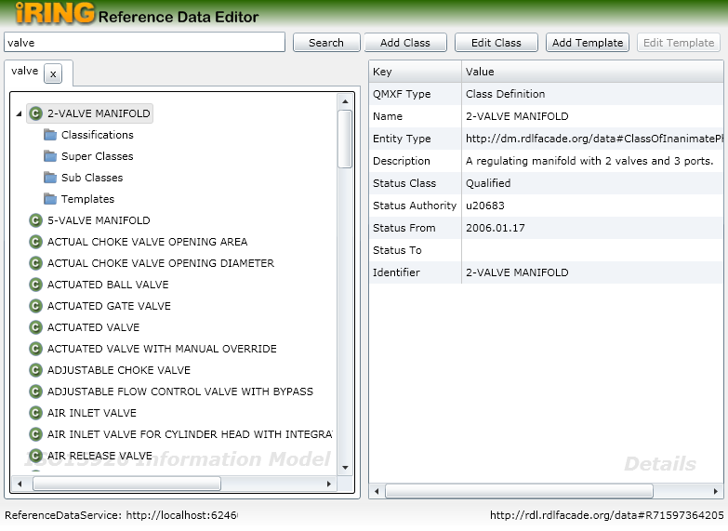

Classifications template will show the “Is Member of” type classes of selected item,
Super Classes template will show the all immediate super classes of selected item,
Sub Classes template will show all immediate sub classes of selected item,
Templates template will show all related templates related to selected class.
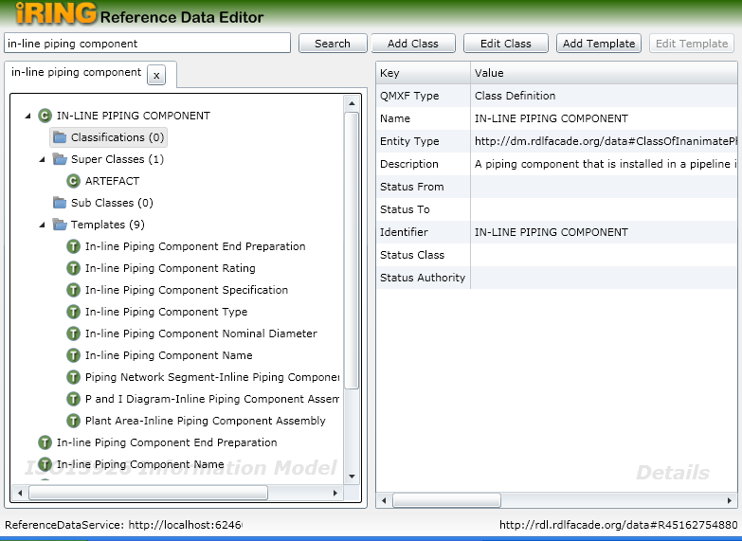

And this selection process can go further to find the complete hierarchy of relationships for any item from search results, like following

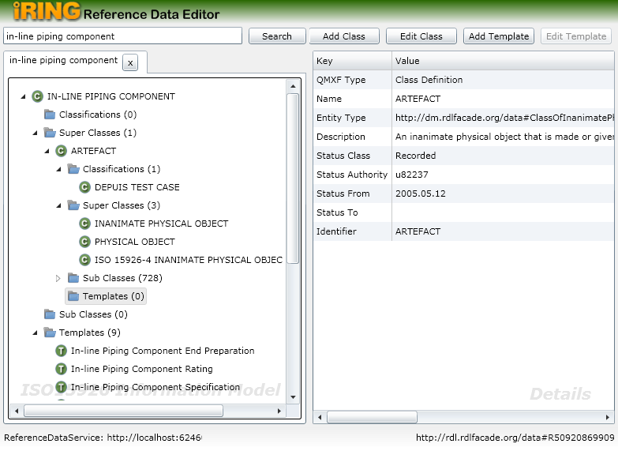

Promoting an item to a new tab window
This feature has been given to provide the facility to the user to promote any selected item to a new tab window so that user can view complete hierarchy of relationships for selected item in a new tab window

Promoting process
- Select any item from search result tab window 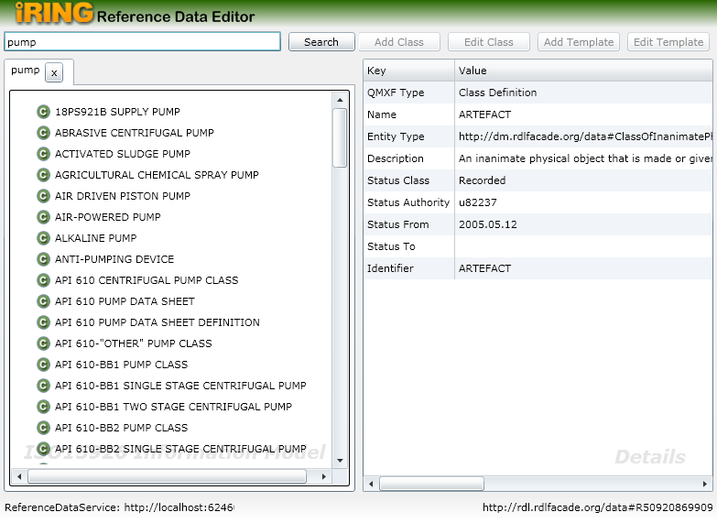

- And then click on ‘Promote’ Button. A new tab window is added to the pane on left side showing the selected items. Now user can view the complete hirarchy of ralationship for that item.
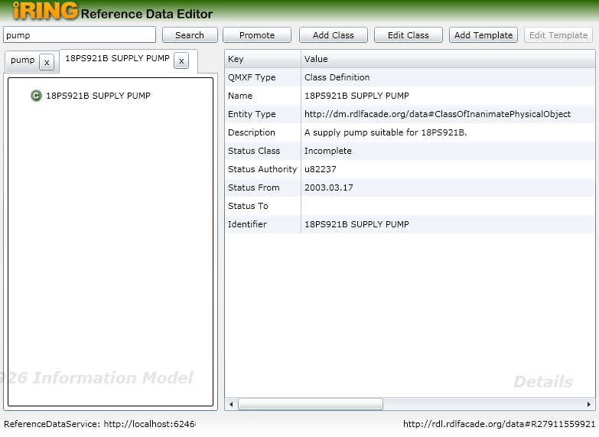

Adding a class into sandbox
This feature has been given to provide the facility to the user to add a new class into sandbox

Add Class pane has following components:
- Name: for providing a name to a new class
- Entity Type: for defining type of entity. This value is made by application
- Description: for providing description to a new class
- Specialization - Add: for providing a set of immediate super classes to a new class
- Specialization - Remove: for removing super classes from the list box above to this button
- Classifications - Add: for providing a set of “Is Member of” type of classes to a new class
- Classifications - Remove: for removing “Is Member of” type of classes from the list box above to this button
- OK: for saving changes in sandbox and user will be navigated to detail pane
- Cancel: for returning to detail pane, if user does not want to add a class
- Apply: for saving changes in sandbox and “Add Class” pane will still be visible to user

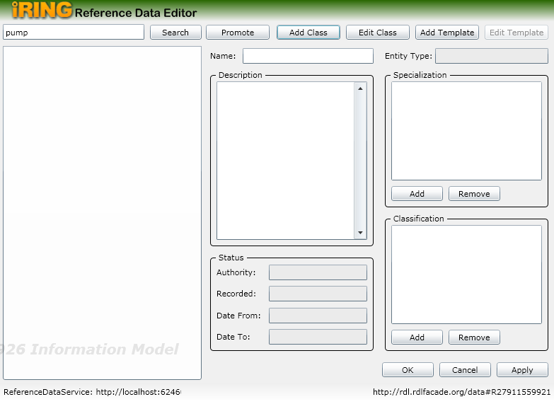

Adding Class process

- Click on Add Class button. A new pane is displayed to right side providing the option to add a class into sandbox

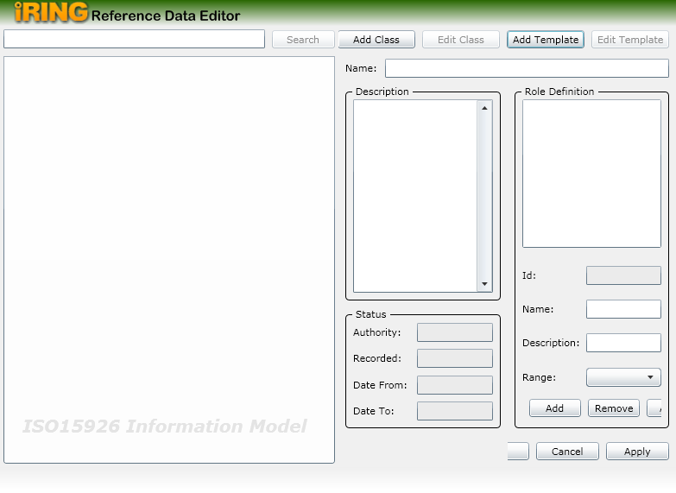
- Provide the name in Name text field to a new class
- Provide the description in Description text box
- Provide a set of immediate super classes to a new class by using Add Button (below Specilization list box)
- Provide a set of “Is Member of” type of classes to a new class by using Add button (below Classification list box)
- Once the user is done with all required entries,
Click on OK, changes will be saved in sandbox and detail pane will be displayed to user
OR
Click on Apply, changes will be saved in sandbox and “Add Class” pane will still be visible to user

Editing Class process

- Select any item from search result pane
- Click on Edit Class button. A new pane is displayed to right side providing the option to edit a class into sandbox with following content
- Name: showing name of selected class
- Entity Type: showing the entity type for selected classs
- Description: showing the description for selected classs
- Specializaion: showing all super classes for selected classs
- Classification: showing all “Is Member Of” type classes for selected classs

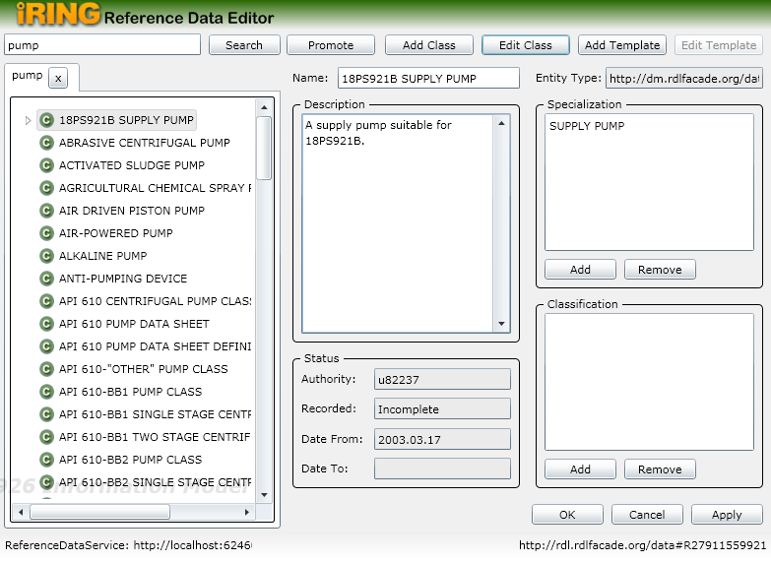

- Now user can make changes in editable field (Name, Description, Specialization, Classification)
- Once the user is done with all required changes, click on OK, changes will be saved in sandbox and detail pane will be displayed to user
OR
Click on Apply, changes will be saved in sandbox and “Add Class” pane will still be visible to user

Adding a template into sandbox
This feature has been given to provide the facility to the user to add a new template into sandbox

Add Template pane has following components:
- Name: for providing a name to a new template
- Description: for providing a description to a new template
- Role Definition: for providing Role Definition to a new template by using controls available in Role Definition pane
- Status: Status entries is made by application
- OK: for saving changes in sandbox and user will be navigated to detail pane
- Cancel: for returning to detail pane, if user does not want to add a template
- Apply: for saving changes in sandbox and “Add Template” pane will still be visible to user

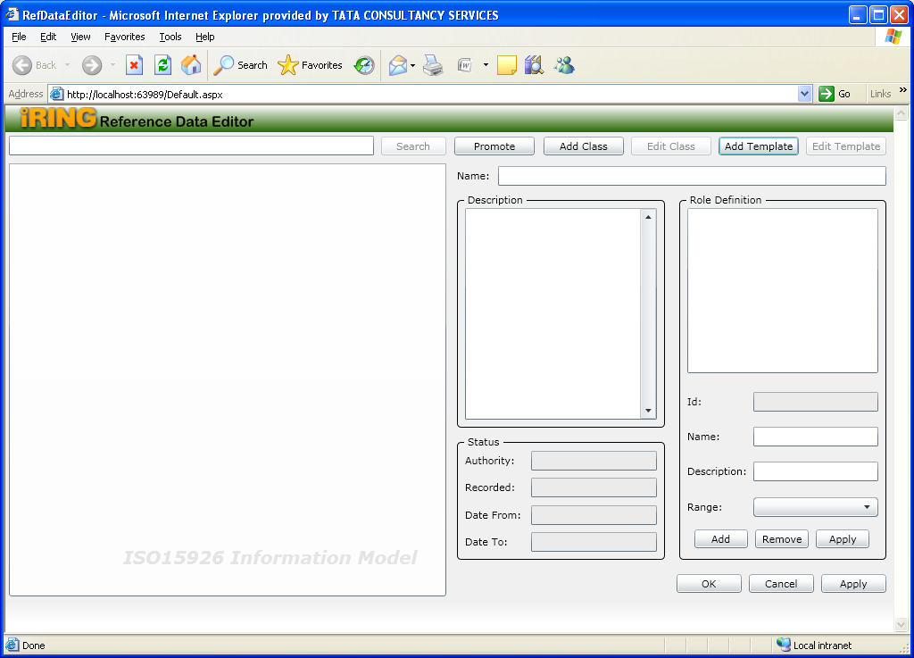

Adding Template process

- Click on Add Template button. A new pane is displayed to right side providing the option to add a template into sandbox
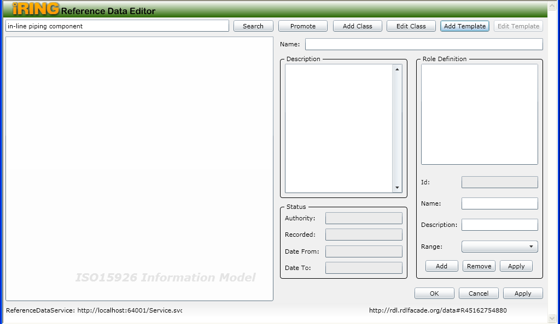
- Provide the name for a new template in Name text box
- Provide the description for a new template in Description text box
- Provide Role Definition by using following steps
- Fill the Name, Description and Range fields in Role Definition Pane.
- Click on Add button in Role Definition Pane to a add a role in Role Definition list box
- Click on Remove button in Role Definition Pane for removing any item from Role Definition list box
- Click on Apply button in Role Definition Pane for specifying a Role Definition for a new template
- Once the user is done with all required entries,
Click on OK, changes will be saved in sandbox and detail pane will be displayed to user
OR
Click on Apply, changes will be saved in sandbox and “Add Template” pane will still be visible to user

Editing Template process

- Select any item of template type from search result pane
- Click on Edit Template button. A new pane is displayed to right side providing the option to edit a template into sandbox with following content
- Name: showing name of selected template
- Description: showing the description for selected template
- Role Definition: showing Role Definition details for selected template

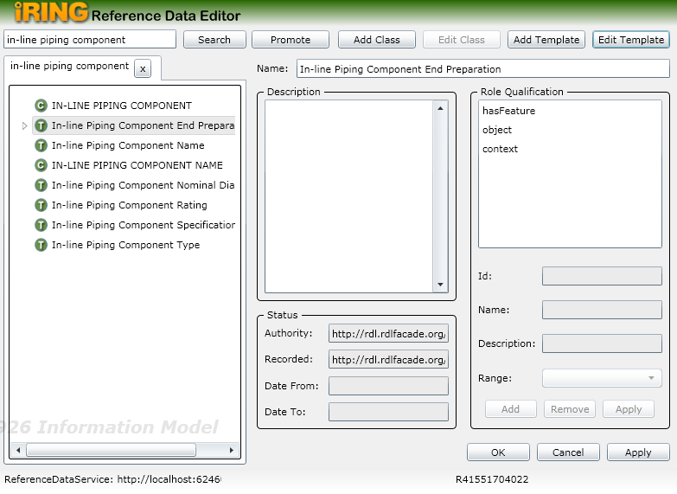

- Now user can make changes in editable field (Name, Description)
- Once the user is done with all required changes,
Click on OK, changes will be saved in sandbox and detail pane will be displayed to user
OR
Click on Apply, changes will be saved in sandbox and “Add Template” pane will still be visible to user

